[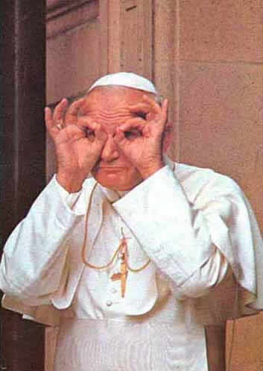](http://www.google.com/url?sa=i&rct=j&q=&esrc=s&source=images&cd=&cad=rja&uact=8&ved=0ahUKEwjWmYia_ZjPAhUDHxoKHZg0DasQjRwIBw&url=http%3A%2F%2Fwww.evangelicaloutreach.org%2Fpope-john-paul-II.htm&psig=AFQjCNGKZuWcBjwsZt_2f6c7bYg0FX8zQw&ust=1474290181391038)[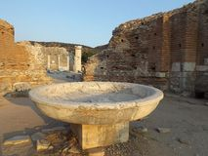](https://www.google.com/url?sa=i&rct=j&q=&esrc=s&source=images&cd=&cad=rja&uact=8&ved=0ahUKEwiy1KDb-ZjPAhXDthoKHWoZBRUQjRwIBw&url=https%3A%2F%2Fwww.dreamstime.com%2Fstock-photo-church-mary-ephesus-turkey-was-one-seven-cities-addressed-book-revelation-clos)[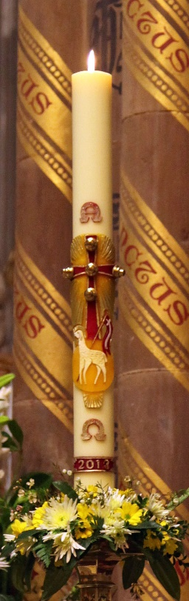](http://www.google.com/url?sa=i&rct=j&q=&esrc=s&source=images&cd=&cad=rja&uact=8&ved=0ahUKEwjU_NXq45jPAhWJPBoKHW4nAJMQjRwIBw&url=http%3A%2F%2Fpeterjennings.co.uk%2F2013%2Farchdiocese-birmingham%2Fwe-must-witness-the-truth-of-christs-rising-from-the-dead-a)

*Site of the Council of Ephesus and proclamation of*

*Our Blessed Lady Mary as “Theotokos”*

*meaning “The God bearer”.*

The Font at the Church of St. Mary, Ephesus.

*“Theotokos”.*

*Mary the God Bearer.*

Parish of St John Paul 11

The Good Shepherd &

St Anthony

(Boni Pastoris),

Serving Arnold,Calverton, Daybrook, Mapperley, Sherwood, Woodthorpe  
  
**Sacrament of Baptism & Christening**

***Dates of future preparation seminars— 2025***

***Seminar Commences at 10:45am in the Parish***

***Centre after 9:45am Mass.***

**Sunday 19th January Sunday 26th Jan & 2nd Feb**

**Sunday 9th March Sunday 16th & 23rd March**

**Sunday 11th May Sunday 18th & 25th May**

**Sunday 6th July Sunday 13th & 20th July**

**Sunday 7th September Sunday 14th & 21st Sept**

**Sunday 2nd November Sunday 9th & 16th Nov**

**What does Church Law say about preparation for Baptism?**

The parents and sponsors are to be properly instructed in the meaning of this Sacrament and the obligation attached to it.

(Can. 851.2)

***Baptisms at the Good Shepherd Church take place on***

***Saturdays at 12 noon***

***Other times by prior arrangement with the Parish Priest.***

***A Seminar of Preparation is held regularly; usually every second month beginning in January - see inside for dates.***

***Seminars are at 10:45a.m. in the Joseph Hall and last for about one hour approximately.***

***Please bring this completed form with you.***

***You will be invited to share a further three parents***

***Seminars in support of your personal spirituality.***

***Dear Parents,***

***Thank you for asking for the baptism of your child. You are the “first teach-ers in the ways of Faith”. We are here to help you as the “best of teachers”.***

***Baptism and Christening is robbed of its meaning if there is no intention of sharing fully in the life of the Church once the Sacrament is celebrated. We hope this form will help you to participate fully in this***

***your local and welcoming Catholic Community.***

***“The Good Shepherd Church: the friendly place”***

Contact for further details:

**The Good Shepherd on (0115) 926 8288**

**Email:**

**GSBaptism@dioceseofnottingham.uk**

***What does Church Law say about sponsors?***

· A Candidate for Baptism should be given a sponsor also known as a God parents (Can. 872)

· Ordinarily only 1 male or 1 female or one of each sex is to be employed. (Can. 873)

· A sponsor must be at least 16 years of age, be a Confirmed Catholic, made 1st Holy Communion & leads a life in harmony with the Faith and the role to be undertaken. They must have the intention of performing this role (Can. 874, 2& 3)

· The parents of the child may not assume the role of sponsor.

(Can 874.5)

***What is Baptism & Christening all about?***

***This leaflet puts before you the main considerations which you as parents will have in mind when you request Baptism for your child in the Catholic Church. Baptism and Christening (one ceremony) is the most significant moment in our lives. As a thing of infinite value you must weigh carefully your intentions and commitment with regard to all that this great gift implies.***

“The future begins today; not tomorrow” Pope John Paul II